SENSING DANGER IN CHESS

By

GM Bong Villamayor

Powerchess Asia

Sensing danger in chess is a unique ability that can be learned and developed.
The constant improvement of our tactics help us identify the many possibilities in a position; it help us recall the numerous patterns that we have solved and assimilate.
But most importantly the anticipation of your opponent’s plans is the key in minimizing danger in many positions.

1) Is Bxe6+ ok? 2) Analyze Bxe4+ 3) What is wrong with B?

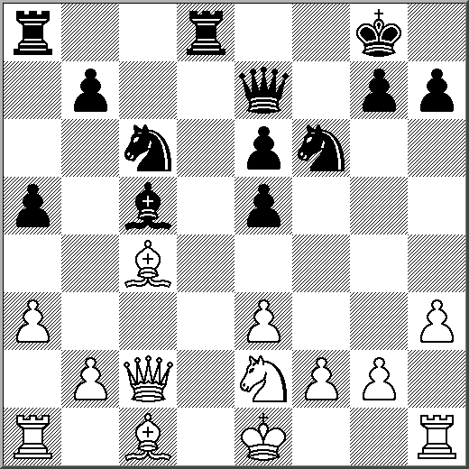
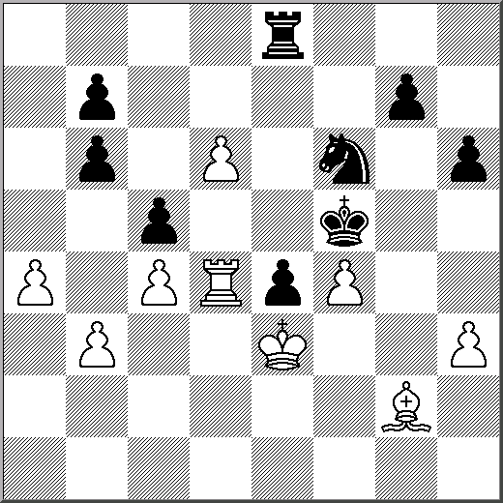
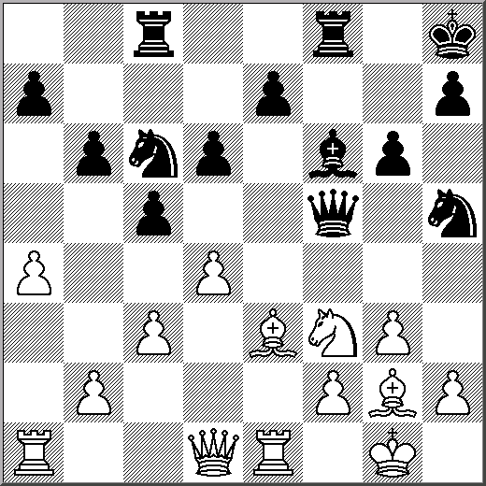

4) Is …Re4 & …Rb2 ok? 5) Is Black’s …Rfd8 ok? 6) Why is Rad1 wrong?
